**1.Implementation of Single Linked list**

**PROGRAM:**

#include<stdio.h>

#include<stdlib.h>

struct node

{

int Element;

struct node *Next;

};

struct node *List;

void insert_beg(struct node *List, int x);

void insert_mid(struct node *List, int pos, int x);

void insert_last(struct node *List, int x);

void display(struct node *List);

void delete_beg(struct node *List);

void delete_mid(struct node *List, int x);

void delete_last(struct node *List);

struct node *Find(struct node *List, int x);

int main()

{

int ch,e,pos;

List=malloc(sizeof(struct node));

List->Next=NULL;

while(1)

{

printf("\n1.Insert begin\n2.Insert Mid \n3.Inseret Last \n4.Delete Begin\n5.Delete Mid \n6.Delete Last  \n7.Display \n8.Exit\n");

printf("\nEnter your choice\n");

scanf("%d",&ch);

switch(ch)

{

case 1:

printf("\nEnter an element to insert\n");

scanf("%d",&e);

insert_beg(List, e);

display(List);

break;

case 2:

printf("\nEnter an element to insert\n");

scanf("%d",&e);

printf("Enter the position to insert\n");

scanf("%d",&pos);

insert_mid(List, pos, e);

display(List);

break;

case 3:

printf("\nEnter an element to insert\n");

scanf("%d",&e);

insert_last(List, e);

display(List);

break;

case 4:

delete_beg(List);

display(List);

break;

case 5:

printf("\nEnter the element to be deleted\n");

scanf("%d",&e);

delete_mid(List, e);

display(List);

break;

case 6:

delete_last(List);

display(List);

break;

case 7:

display(List);

break;

case 8:

exit(0);

}

}

return 0;

}

void insert_beg(struct node *List, int x)

{

struct node *NewNode;

NewNode = malloc(sizeof(struct node));

NewNode->Element = x;

if(List->Next == NULL)

NewNode->Next = NULL;

else

NewNode->Next = List->Next;

List->Next = NewNode;

}

void display(struct node *List)

{

if(List->Next != NULL)

{

struct node *Position;

Position=List;

printf("\nList is ");

while(Position->Next != NULL)

{

Position = Position->Next;

printf("%d ", Position->Element);

}

printf("\n");

}

else

printf("\nEmpty List\n");

}

void insert_mid(struct node *List, int pos, int x)

{

struct node *NewNode, *Position;

NewNode = malloc(sizeof(struct node));

NewNode->Element = x;

Position=Find(List, pos);

NewNode->Next = Position->Next;

Position->Next = NewNode;

}

struct node *Find(struct node *List, int x)

{

struct node *Position;

Position = List->Next;

while(Position != NULL && Position->Element != x)

Position = Position->Next;

return Position;

}

struct node *FindPrevious(struct node *List, int x)

{

struct node *Position;

Position = List;

while(Position->Next != NULL && Position->Next->Element != x)

Position = Position->Next;

return Position;

}

void insert_last(struct node *List, int e)

{

struct node *NewNode, *Position;

NewNode= malloc(sizeof(struct node));

NewNode->Element = e;

NewNode->Next = NULL;

if(List->Next==NULL)

List->Next = NewNode;

else

{

Position = List;

while(Position->Next != NULL)

Position = Position->Next;

Position->Next = NewNode;

}

}

void delete_beg(struct node *List)

{

if(List->Next != NULL)

{

struct node *TempNode;

TempNode = List->Next;

List->Next = TempNode->Next;

printf("The deleted item is %d\n", TempNode->Element);

free(TempNode);

}

else

printf("\nEmpty List\n");

}

void delete_mid(struct node *List, int e)

{

if(List->Next != NULL)

{

struct node *TempNode, *Position;

Position = FindPrevious(List, e);

if(Position->Next != NULL)

{

TempNode = Position->Next;

Position->Next = TempNode->Next;

printf("The deleted item is %d\n", TempNode->Element);

free(TempNode);

}

}

else

printf("\nEmpty List\n");

}

void delete_last(struct node *List)

{

if(List->Next != NULL)

{

struct node *TempNode, *Position;

Position = List;

while(Position->Next->Next != NULL)

Position = Position->Next;

TempNode = Position->Next;

Position->Next = NULL;

printf("The deleted item is %d\n", TempNode->Element);

free(TempNode);

}

else

{

printf("\nEmpty List\n");

}

}

**OUTPUT:**

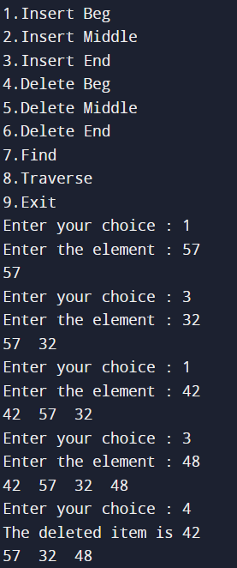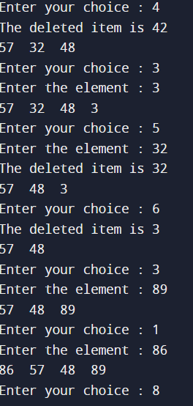

**2. IMPLEMENTATION OF DOUBLE LINKED LIST:**

**PROGRAM:**

#include <stdio.h>

#include <stdlib.h>

struct node

{

   struct node *Prev;

   int Element;

   struct node *next;

};

struct node *find(struct node *list, int x);

void insertbeg(struct node *list, int e);

void InsertLast(struct node *list, int e);

void InsertMid(struct node *list, int p, int e);

void DeleteBeg(struct node *list);

void deleteend(struct node *list);

void deletemid(struct node *list, int e);

void display(struct node *list);

int main()

{

struct node *list = malloc(sizeof(struct node));

list->Prev = NULL;

list->next = NULL;

struct node *position;

int ch, e, p;

printf("1.Insert Beg \n2.Insert Middle \n3.Insert End");

printf("\n4.Delete Beg \n5.Delete Middle \n6.Delete End");

printf("\n7.find \n8.display \n9.Exit\n");

while(1)

{

printf("Enter your choice : ");

scanf("%d", &ch);

switch(ch)

{

case 1:

printf("Enter the element : ");

scanf("%d", &e);

insertbeg(list, e);

display(list);

break;

case 2:

printf("Enter the position element : ");

scanf("%d", &p);

printf("Enter the element : ");

scanf("%d", &e);

InsertMid(list, p, e);

display(list);

break;

case 3:

printf("Enter the element : ");

scanf("%d", &e);

InsertLast(list, e);

display(list);

break;

case 4:

DeleteBeg(list);

display(list);

break;

case 5:

printf("Enter the element : ");

scanf("%d", &e);

deletemid(list, e);

display(list);

break;

case 6:

deleteend(list);

display(list);

break;

case 7:

printf("Enter the element : ");

scanf("%d", &e);

position = find(list, e);

if(position != NULL)

printf("Element found...!\n");

else

printf("Element not found...!\n");

break;

case 8:

display(list);

break;

    case 9:

exit(0);

break;

}

}

return 0;

}

struct node *find(struct node *list, int x)

{

struct node *position;

position = list->next;

while(position != NULL && position->Element != x)

position = position->next;

return position;

}

void insertbeg(struct node *list, int e)

{

struct node *newnode = malloc(sizeof(struct node));

newnode->Element = e;

if(list->next==NULL)

newnode->next = NULL;

else

{

newnode->next = list->next;

newnode->next->Prev = newnode;

}

newnode->Prev = list;

list->next = newnode;

}

void InsertLast(struct node *list, int e)

{

struct node *newnode = malloc(sizeof(struct node));

struct node *position;

newnode->Element = e;

newnode->next = NULL;

if(list->next==NULL)

{

newnode->Prev = list;

list->next = newnode;

}

else

{

position = list;

while(position->next != NULL)

position = position->next;

position->next = newnode;

newnode->Prev = position;

}

}

void InsertMid(struct node *list, int p, int e)

{

struct node *newnode = malloc(sizeof(struct node));

struct node *position;

position = find(list, p);

newnode->Element = e;

newnode->next = position->next;

position->next->Prev = newnode;

position->next = newnode;

newnode->Prev = position;

}

void DeleteBeg(struct node *list)

{

if(list->next!=NULL)

{

struct node *tempnode;

tempnode = list->next;

list->next = tempnode->next;

if(list->next != NULL)

{

tempnode->next->Prev = list;

printf("The deleted item is %d\n", tempnode->Element);

free(tempnode);

}

else

printf("list is empty...!\n");

}

void deleteend(struct node *list)

{

if(list->next!=NULL)

{

struct node *position;

struct node *tempnode;

position = list;

while(position->next != NULL)

position = position->next;

tempnode = position;

position->Prev->next = NULL;

printf("The deleted item is %d\n", tempnode->Element);

free(tempnode);

}

else

printf("list is empty...!\n");

}

void deletemid(struct node *list, int e)

{

if(list->next!=NULL)

{

struct node *position;

struct node *tempnode;

position = find(list, e);

if(position->next!=NULL)

{

tempnode = position;

position->Prev->next = position->next;

position->next->Prev = position->Prev;

printf("The deleted item is %d\n", tempnode->Element);

free(tempnode);

    }

}

else

printf("list is empty...!\n");

}

void display(struct node *list)

{

if(list->next!=NULL)

{

struct node *position;

position = list;

while(position->next!= NULL)

{

position = position->next;

printf("%d\t", position->Element);

}

printf("\n");

}

else

printf("list is empty...!\n");

}

}

**OUTPUT:**

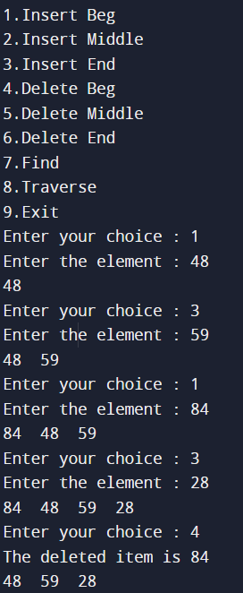

3. **Polynomial Manipulation:(Application of singly linked list)**

Program:

#include <stdio.h>

#include <stdlib.h>

struct poly

{

int coeff;

int pow;

struct poly *Next;

};

typedef struct poly Poly;

void Create(Poly *List);

void Display(Poly *List);

void Addition(Poly *Poly1, Poly *Poly2, Poly *Result);

int main()

{

Poly *Poly1 = malloc(sizeof(Poly));

Poly *Poly2 = malloc(sizeof(Poly));

Poly *Result = malloc(sizeof(Poly));

Poly1->Next = NULL;

Poly2->Next = NULL;

printf("Enter the values for first polynomial :\n");

Create(Poly1);

printf("The polynomial equation is : ");

Display(Poly1);

printf("\nEnter the values for second polynomial :\n");

Create(Poly2);

printf("The polynomial equation is : ");

Display(Poly2);

Addition(Poly1, Poly2, Result);

printf("\nThe polynomial equation addition result is : ");

Display(Result);

return 0;

}

void Create(Poly *List)

{

int choice;

Poly *Position, *NewNode;

Position = List;

do

{

NewNode = malloc(sizeof(Poly));

printf("Enter the coefficient : ");

scanf("%d", &NewNode->coeff);

printf("Enter the power : ");

scanf("%d", &NewNode->pow);

NewNode->Next = NULL;

Position->Next = NewNode;

Position = NewNode;

printf("Enter 1 to continue : ");

scanf("%d", &choice);

} while(choice == 1);

}

void Display(Poly *List)

{

Poly *Position;

Position = List->Next;

while(Position != NULL)

{

printf("%dx^%d", Position->coeff, Position->pow);

Position = Position->Next;

if(Position != NULL && Position->coeff > 0)

{

printf("+");

}

}

}

void Addition(Poly *Poly1, Poly *Poly2, Poly *Result)

{

Poly *Position;

Poly *NewNode;2

Poly1 = Poly1->Next;

Poly2 = Poly2->Next;

Result->Next = NULL;

Position = Result;

while(Poly1 != NULL && Poly2 != NULL)

{

NewNode = malloc(sizeof(Poly));

if(Poly1->pow == Poly2->pow)

{

NewNode->coeff = Poly1->coeff + Poly2->coeff;

NewNode->pow = Poly1->pow;

Poly1 = Poly1->Next;

Poly2 = Poly2->Next;

}

else if(Poly1->pow > Poly2->pow)

{

NewNode->coeff = Poly1->coeff;

NewNode->pow = Poly1->pow;

Poly1 = Poly1->Next;

}

else if(Poly1->pow < Poly2->pow)

{

NewNode->coeff = Poly2->coeff;

NewNode->pow = Poly2->pow;

Poly2 = Poly2->Next;

}

NewNode->Next = NULL;

Position->Next = NewNode;

Position = NewNode;

}

while(Poly1 != NULL || Poly2 != NULL)

{

NewNode = malloc(sizeof(Poly));

if(Poly1 != NULL)

{

NewNode->coeff = Poly1->coeff;

NewNode->pow = Poly1->pow;

Poly1 = Poly1->Next;

}

if(Poly2 != NULL)

{

NewNode->coeff = Poly2->coeff;

NewNode->pow = Poly2->pow;

Poly2 = Poly2->Next;

}

NewNode->Next = NULL;

Position->Next = NewNode;

Position = NewNode;

}

}

output

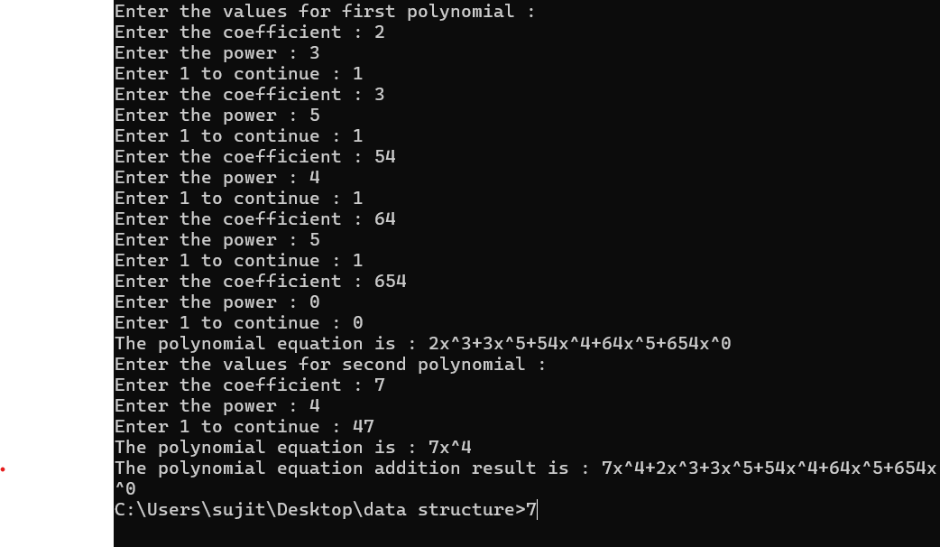

SUBTRACTION:

#include <stdio.h>

#include <stdlib.h>

struct poly {

int coeff;

int pow;

struct poly *Next;

};

typedef struct poly Poly;

void Create(Poly *List);

void Display(Poly *List);

void Subtraction(Poly *Poly1, Poly *Poly2, Poly *Result);

int main() {

Poly *Poly1 = malloc(sizeof(Poly));

Poly *Poly2 = malloc(sizeof(Poly));

Poly *Result = malloc(sizeof(Poly));

Poly1->Next = NULL;

Poly2->Next = NULL;

printf("Enter the values for first polynomial :\n");

Create(Poly1);

printf("The polynomial equation is : ");

Display(Poly1);

printf("\nEnter the values for second polynomial :\n");

Create(Poly2); printf("The polynomial equation is : ");

Display(Poly2); Subtraction(Poly1, Poly2, Result);

printf("\nThe polynomial equation subtraction result is : ");

Display(Result);

return 0;

}

void Create(Poly *List)

{

int choice;

Poly *Position, *NewNode;

Position = List;

do

{

NewNode = malloc(sizeof(Poly));

printf("Enter the coefficient : ");

scanf("%d", &NewNode->coeff);

printf("Enter the power : ");

scanf("%d", &NewNode->pow);

NewNode->Next = NULL;

Position->Next = NewNode;

Position = NewNode;

printf("Enter 1 to continue : ");

scanf("%d", &choice);

}while(choice == 1);

}

void Display(Poly *List)

{

Poly *Position; Position = List->Next;

while(Position != NULL)

{

printf("%dx^%d", Position->coeff, Position->pow);

Position = Position->Next;

if(Position != NULL && Position->coeff > 0)

{

printf("+");

}

}

}

void Subtraction(Poly *Poly1, Poly *Poly2, Poly *Result)

{

Poly *Position;

Poly *NewNode;

Poly1 = Poly1->Next;

Poly2 = Poly2->Next;

Result->Next = NULL;

Position = Result;

while(Poly1 != NULL && Poly2 != NULL)

{

NewNode = malloc(sizeof(Poly));

if(Poly1->pow == Poly2->pow)

{

NewNode->coeff = Poly1->coeff - Poly2->coeff;

NewNode->pow = Poly1->pow;

Poly1 = Poly1->Next;

Poly2 = Poly2->Next;

}

else if(Poly1->pow > Poly2->pow)

{

NewNode->coeff = Poly1->coeff;

NewNode->pow = Poly1->pow;

Poly1 = Poly1->Next;

}

else if(Poly1->pow < Poly2->pow)

{

NewNode->coeff = -(Poly2->coeff);

NewNode->pow = Poly2->pow;

Poly2 = Poly2->Next;

}

NewNode->Next = NULL;

Position->Next = NewNode;

Position = NewNode;

}

while(Poly1 != NULL || Poly2 != NULL)

{

NewNode = malloc(sizeof(Poly));

if(Poly1 != NULL)

{

NewNode->coeff = Poly1->coeff;

NewNode->pow = Poly1->pow;

Poly1 = Poly1->Next;

}

if(Poly2 != NULL)

{

NewNode->coeff = -(Poly2->coeff);

NewNode->pow = Poly2->pow;

Poly2 = Poly2->Next;

}

NewNode->Next = NULL;

Position->Next = NewNode;

Position = NewNode;

}

4. IMPLEMENTATION OF **STACK USING ARRAY AND**

**LINKED LIST IMPLEMENTATION**

**PROGRAM:**

#include<stdio.h>

#include<stdlib.h>

#define size 5

int Stack[size], top = -1;

void Push(int ele);

void Pop();

void Top();

void Display();

int main()

{

int ch, e;

while(1)

{

printf("1.PUSH\n 2.POP\n 3.TOP\n 4.DISPLAY\n 5.EXIT ");

printf("\nEnter your choice : ");

scanf("%d", &ch);

switch(ch)

{

case 1:

printf("Enter the element : ");

scanf("%d",&e);

Push(e);

break;

case 2:

Pop();

break;

case 3:

Top();

break;

case 4:

Display();

break;

case 5:

exit(0);

}

}

}

void Push(int ele)

{

if(top==size-1)

printf("Stack Overflow\n");

else

{

top = top + 1;

Stack[top] = ele;

}

}

void Pop()

{

if(top == -1)

printf("Stack Underflow\n");

else

{

printf("%d\n", Stack[top]);

top = top - 1;

}

}

void Top()

{

if(top == -1)

printf("Stack Underflow\n");

else

printf("%d\n", Stack[top]);

}

void Display()

{

if(top == -1)

printf("Stack Underflow\n");

else

{

for(int i = top;i>= 0; i--)

printf("%d\t", Stack[i]);

printf("\n");

}

OUTPUT:

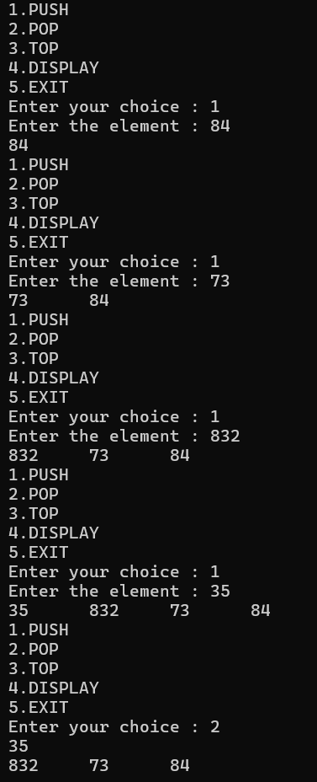

**STACK USING LINKED LIST**

PROGRAM:

**#include <stdio.h>**

**#include <stdlib.h>**

**struct node**

**{**

**int Element;**

**struct node *Next;**

**};**

**struct node *top = NULL;**

**void Push(int e);**

**void Pop();**

**void Top();**

**void Display();**

**int main()**

**{**

**int ch, e;**

**while(1)**

**{**

**printf("1.PUSH\n 2.POP\n 3.TOP\n 4.DISPLAY\n 5.EXIT\n");**

**printf("\nEnter your choice : ");**

**scanf("%d", &ch);**

**switch(ch)**

**{**

**case 1:**

**printf("Enter the element : ");**

**scanf("%d", &e);**

**Push(e);**

**Display();**

**break;**

**case 2:**

**Pop();**

**Display();**

**break ;**

**case 3:**

**Top();**

**Display();**

**break;**

**case 4:**

**Display();**

**break;**

**case 5:**

**exit(0);**

**}**

**}**

**return 0;**

**}**

**void Push(int e)**

**{**

**struct node *NewNode = malloc(sizeof(struct node));**

**NewNode->Element = e;**

**if(top == NULL)**

**NewNode->Next = NULL;**

**else**

**NewNode->Next = top;**

**top = NewNode;**

**}**

**void Pop()**

**{**

**if(top==NULL)**

**printf("Stack is Underflow...!\n");**

**else**

**{**

**struct node *tempNode;**

**tempNode = top;**

**top = top->Next;**

**printf("%d\n", tempNode->Element);**

**free(tempNode);**

**}**

**}**

**void Top()**

**{**

**if(top==NULL)**

**printf("Stack is Underflow...!\n");**

**else**

**printf("%d\n",top->Element);**

**}**

**void Display()**

**{**

**if(top==NULL)**

**printf("Stack is Underflow...!\n");**

**else**

**{**

**struct node *position;**

**position = top;**

**while(position != NULL)**

**{**

**printf("%d\t", position->Element);**

**position = position->Next;**

**}**

**printf("\n");**

OUTPUT:

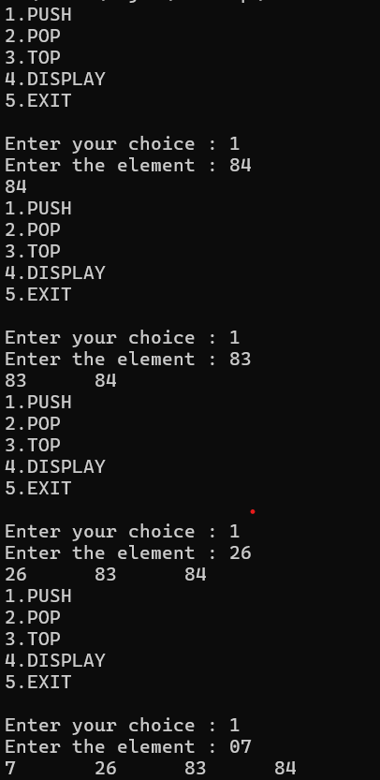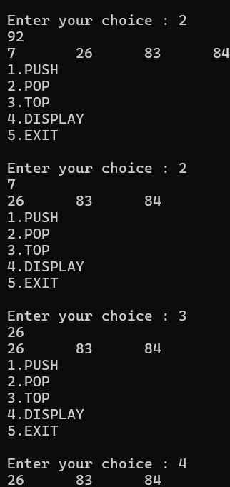

**IMPLEMENTATION OF QUEUE USING ARRAY AND LINKED LIST IMPLEMENTATION**

**#include <stdio.h>**

**#include<stdlib.h>**

**#define MAX 5**

**int queue[size], front = -1, rear = -1;**

**void enqueue(int ele);**

**void dequeue();**

**void display();**

**int main()**

**{**

**int ch, e;**

**while(1)**

**{**

**printf("1.ENQUEUE\n 2.DEQUEUE\n 3.DISPLAY\n 4.EXIT\n");**

**printf("\nEnter your choice : ");**

**scanf("%d", &ch);**

**switch(ch)**

**{**

**case 1:**

**printf("Enter the element : ");**

**scanf("%d", &e);**

**enqueue();**

**display();**

**break;**

**case 2:**

**dequeue();**

**display();**

**break;**

**case 3:**

**display();**

**break;**

**case 4:**

**exit(0);**

**}**

**}**

**}**

**void enqueue(int ele)**

**{**

**if(rear ==size - 1)**

**printf("Queue is Overflow\n");**

**else**

**{**

**rear = rear + 1;**

**Queue[rear] = ele;**

**if(front == -1)**

**front = 0;**

**}**

**}**

**void dequeue()**

**{**

**if(front == -1)**

**printf("Queue is Underflow\n");**

**else**

**{**

**printf("%d\n", Queue[front]);**

**if(front == rear)**

**front = rear = -1;**

**else**

**front = front + 1;**

**}**

**}**

**void display()**

**{**

**if(front==-1)**

**printf("Queue is Underflow.\n");**

**else**

**{**

**for(int i = front; i <= rear; i++)**

**printf("%d\t", Queue[i]);**

**printf("\n");**

**}**

**}**

**OUTPUT:**

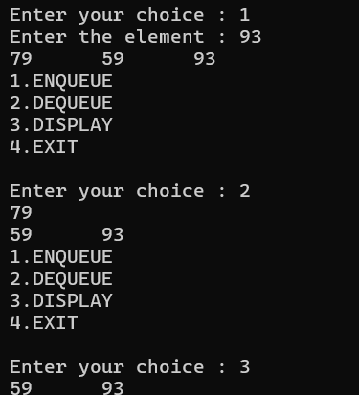

QUEUE USING LINKED LIST

#include <stdio.h>

#include <stdlib.h>

struct node

{

int Element;

struct node *next;

};

struct node *list=NULL;

struct node *front = NULL;

struct node *rear = NULL;

void enqueue(int ele);

void dequeue();

void display();

int main()

{

int ch, e;

while(1)

{

printf("1.ENQUEUE\n2.DEQUEUE\n3.DISPLAY\n4.EXIT");

printf("\nEnter your choice : ");

scanf("%d", &ch);

switch(ch)

{

case 1:

printf("Enter the element : ");

scanf("%d", &e);

enqueue(e);

display();

break;

case 2:

dequeue();

display();

break;

case 3:

display();

break;

case 4:

exit(0);

}

}

return 0;

}

void enqueue(int e)

{

struct node *newnode = malloc(sizeof(struct node));

newnode->Element = e;

newnode->next = NULL;

if(rear == NULL)

front = rear = newnode;

else

{

rear->next = newnode;

rear = newnode;

}

}

void dequeue()

{

if(list!=NULL)

printf("Queue is Underflow\n");

else

{

struct node *tempnode;

tempnode = front;

if(front == rear)

front = rear = NULL;

else

front = front->next;

printf("%d\n", tempnode->Element);

free(tempnode);

}

}

void display()

{

if(list!=NULL)

printf("Queue is Underflow\n");

else

{

struct node *position;

position = front;

while(position != NULL)

{

printf("%d\t", position->Element);

position = position->next;

}

printf("\n");

}

}

OUTPUT:

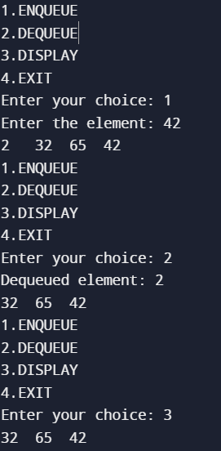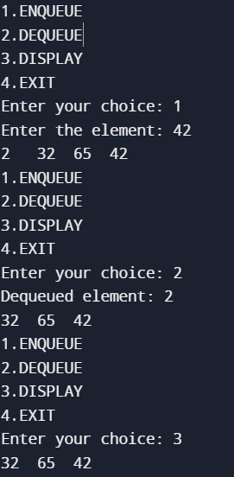

**9.Implementation Of Binary Search Tree**

#include <stdio.h>

#include <stdlib.h>

struct Node {

int data;

struct Node* left;

struct Node* right;

};

struct Node* createNode (int value)

{

struct Node* newNode = (structNode*)malloc(sizeof(struct Node));

newNode->data = value;

newNode->left = NULL;

newNode->right = NULL;

return newNode;

}

struct Node* insert(struct Node* root, int value)

{

if (root == NULL)

{

return;

createNode(value);

}

if (value < root->data)

{

root->left = insert(root->left, value);

}

else if (value > root>data)

{

root->right = insert(root>right, value);

}

return root;

}

struct Node* minValueNode(struct Node* node)

{

struct Node* current = node;

while (current && current->left != NULL) { current = current>left;

}

return current;

}

struct Node* deleteNode(struct Node* root, int value)

{

if (root == NULL)

{

return root;

}

if (value < root->data)

{

root->left = deleteNode(root->left, value);

}

else if (value > root>data)

{

root->right = deleteNode(root->right, value); } else { if (root->left ==

NULL)

{

struct Node* temp = root->right; free(root); return temp;

}

else if (root->right == NULL)

{

struct Node* temp = root->left;

free(root);

return temp;

}

struct Node* temp = minValueNode(root->right);

root->data = temp>data;

root->right = deleteNode(root->right, temp->data);

}

return root;

}

struct Node* search(struct Node* root, int value)

{

if (root == NULL || root>data == value)

{

return root;

}

if (root->data < value)

{

return search(root->right, value);

}

return search(root->left, value);

}

void display(struct Node* root)

{

if (root != NULL)

{

display(root->left);

printf("%d ", root>data);

display(root->right);

}

}

int main() {

struct Node* root = NULL;

root = insert(root, 50);

insert(root, 30);

insert(root, 20);

insert(root, 40);

insert(root, 70);

insert(root, 60);

insert(root, 80);

printf("Binary Search Tree Inorder Traversal: ");

display(root);

printf("\n");

root = deleteNode(root, 20);

printf("Binary Search Tree Inorder Traversal after deleting 20: ");

display(root);

printf("\n");

struct Node* searchResult = search(root, 30);

if (searchResult != NULL)

{

printf("Element 30 found in the Binary Search Tree.\n");

}

Else

{

printf("Element 30 not found in the Binary Search Tree.\n");

}

return 0;

}

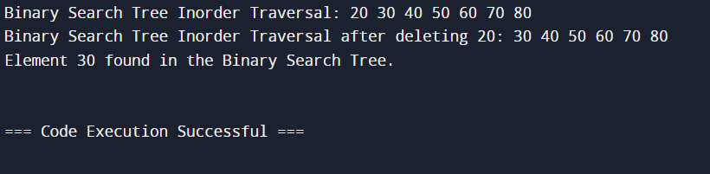

**10. IMPLEMENTATION OF AVL TREE**

Program:

#include <stdio.h>

#include <stdlib.h>

typedef struct Node

{

int data;

struct Node *left;

struct Node *right;

int height;

}

Node;

//Function to get the height of a node int height(Node *node)

{

if (node == NULL)

return 0;

return node->height;

}

// Function to get the balance factor of a node

int balance_factor(Node *node)

{

if (node == NULL)

return 0;

return height(node->left) - height(node->right);

}

// Function to create a new node

Node* newNode(int data) {

Node* node = (Node*)malloc(sizeof(Node));

node->data = data;

node->left = NULL;

node->right = NULL;

node->height = 1;

return node;

}

// Function to perform a right rotation

Node* rotate_right(Node *y) {

Node *x = y->left;

Node *T2 = x->right;

// Perform rotation

x->right = y; y->left = T2;

// Update heights

y->height = 1 + (height(y->left) > height(y->right) ? height(y->left) : height(y->right));

x->height = 1 + (height(x->left) > height(x->right) ? height(x->left) : height(x>right));

return x;

}

// Function to perform a left rotation

Node* rotate_left(Node *x) {

Node *y = x->right;

Node *T2 = y->left;

// Perform rotation

y->left = x;

x->right = T2;

// Update heights

x->height = 1 + (height(x->left) > height(x->right) ? height(x->left) : height(x->right));

y->height = 1 + (height(y->left) > height(y->right) ? height(y->left) : height(y>right));

return y;

}

// Function to insert a node into AVL tree Node* insert(Node *node, int data) { if (node == NULL)

return newNode(data);

if (data < node->data)

node->left = insert(node->left, data); else if (data > node->data)

node->right = insert(node->right, data); else // Duplicate keys not allowed

return node;

// Update height of current node node->height = 1 + (height(node->left) > height(node->right) ? height(node->left) : height(node->right));

// Get the balance factor int balance = balance_factor(node);

// Perform rotations if needed

if (balance > 1 && data < node->left->data)

return rotate_right(node);

if (balance < -1 && data > node->right->data) return rotate_left(node); if (balance > 1 && data> node->left->data)

{

node->left = rotate_left(node->left);

return rotate_right(node);

}

if (balance < -1 && data < node->right->data) { node->right = rotate_right(node->right); return rotate_left(node);

}

return node;

}

// Function to find the node with minimum value

Node* minValueNode(Node *node)

{ Node* current = node;

while (current->left != NULL)

current = current->left; return current;

}

// Function to delete a node from AVL tree Node* deleteNode(Node *root, int data)

{

if (root == NULL)

return root;

if (data < root->data)

root->left = deleteNode(root->left, data);

else if (data > root->data)

root->right = deleteNode(root->right, data);

else

{

if (root->left == NULL || root->right == NULL)

{

Node *temp = root->left ? root->left : root->right;

if (temp == NULL) {

temp = root;

root = NULL;

} else

*root = *temp; // Copy the contents of the non-empty child

free(temp);

} else

{

Node *temp = minValueNode(root->right);

root->data = temp->data;

root->right = deleteNode(root->right, temp->data);

}

}

if (root == NULL)

return root;

// Update height of current node

root->height = 1 + (height(root->left) > height(root->right) ? height(root->left) : height(root->right));

// Get the balance factor

int balance = balance_factor(root);

// Perform rotations if needed

if (balance > 1 && balance_factor(root->left) >= 0)

return rotate_right(root);

if (balance > 1 && balance_factor(root->left) < 0) {

root->left = rotate_left(root->left);

return rotate_right(root);

}

if (balance < -1 && balance_factor(root->right) <= 0)

return rotate_left(root);

if (balance < -1 && balance_factor(root->right) > 0) {

root->right = rotate_right(root->right);

return rotate_left(root);

}

return root;

}

// Function to print AVL tree inorder

void inorder(Node *root)

{ if (root != NULL) {

inorder(root->left);

printf("%d ", root->data);

inorder(root->right);

}

}

int main() {

Node *root = NULL;

// Inserting nodes

root = insert(root, 10);

root = insert(root, 20);

root = insert(root, 30);

root = insert(root, 40);

root = insert(root, 50);

root = insert(root, 25);

printf("Inorder traversal of the constructed AVL tree: ");

inorder(root);

printf("\n");

// Deleting node

printf("Delete node 30\n");

root = deleteNode(root, 30);

printf("Inorder traversal after deletion: ");

inorder(root);

printf("\n");

return 0;

}

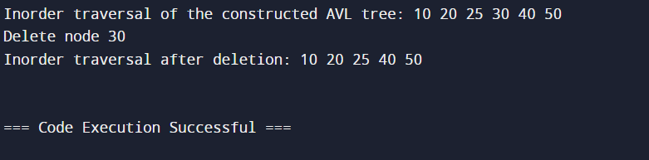

**11.IMPLEMENTATION OF BFS,DFS**

Program:

#include <stdio.h>

#define MAX_VERTICES 10

int graph[MAX_VERTICES][MAX_VERTICES] = {0};

int visited[MAX_VERTICES] = {0}; int vertices;

void createGraph()

{

int i, j;

printf("Enter the number of vertices: "); scanf("%d", &vertices);

printf("Enter the adjacency matrix:\n");

for (i = 0; i < vertices; i++)

{

for (j = 0; j < vertices; j++)

{

scanf("%d", &graph[i][j]);

}

}

}

void dfs(int vertex)

{

int i;

printf("%d ", vertex);

visited[vertex] = 1;

for (i = 0; i < vertices; i++)

{

if (graph[vertex][i] && !visited[i])

dfs(i);

}

}

int main() {

int i;

createGraph();

printf("Ordering of vertices after DFS traversal:\n");

for (i = 0; i < vertices; i++)

{

if (!visited[i])

{

dfs(i);

}

}

    return 0;

}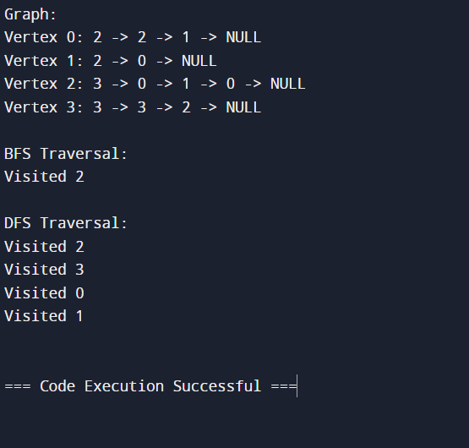

**12. PERFORMING TOPOLOGICAL SORTING**

Program:

#include <stdio.h>

#define MAX_VERTICES 10

int graph[MAX_VERTICES][MAX_VERTICES] = {0};

int visited[MAX_VERTICES] = {0}; int vertices;

void createGraph()

{

int i, j;

printf("Enter the number of vertices: "); scanf("%d", &vertices);

printf("Enter the adjacency matrix:\n");

for (i = 0; i < vertices; i++)

{

for (j = 0; j < vertices; j++)

{

scanf("%d", &graph[i][j]);

}

}

}

void dfs(int vertex)

{

int i;

printf("%d ", vertex);

visited[vertex] = 1;

for (i = 0; i < vertices; i++)

{

if (graph[vertex][i] && !visited[i])

dfs(i);

}

}

int main() {

int i;

createGraph();

printf("Ordering of vertices after DFS traversal:\n");

for (i = 0; i < vertices; i++)

{

if (!visited[i])

{

dfs(i);

}

}

    return 0;

}

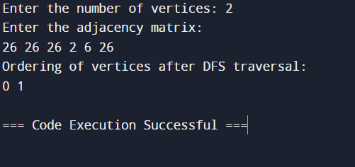

**13. IMPLEMENTATION OF PRIM'S ALGORITHM**

Program:

#include <stdio.h>

#include <stdbool.h>

#define MAX_VERTICES 10

#define INF 999999

int graph[MAX_VERTICES][MAX_VERTICES];

int vertices;

void createGraph()

{

int i, j;

printf("Enter the number of vertices: ");

scanf("%d", &vertices);

printf("Enter the adjacency matrix:\n");

for (i = 0; i < vertices; i++)

{

for (j = 0; j < vertices; j++)

scanf("%d", &graph[i][j]);

}

}

int findMinKey(int key[], bool mstSet[])

{

int min = INF, min_index;

for (int v = 0; v < vertices; v++)

{

if (mstSet[v] == false && key[v] < min)

{

min = key[v];

min_index = v;

}

}

return min_index;

}

void printMST(int parent[])

{

printf("Edge \tWeight\n");

for (int i = 1; i < vertices; i++

{

printf("%d - %d \t%d \n", parent[i], i, graph[i][parent[i]]);

}

}

void primMST()

{

int parent[vertices];

int key[vertices];

bool mstSet[vertices];

for (int i = 0; i < vertices; i++)

{

key[i] = INF;

mstSet[i] = false;

}

key[0] = 0;

// Make key 0 so that this vertex is picked as the first vertex

parent[0] = -1;

// First node is always root of MST

for (int count = 0; count < vertices - 1; count++)

{

int u = findMinKey(key, mstSet);

mstSet[u] = true;

for (int v = 0; v < vertices; v++)

{

if (graph[u][v] && mstSet[v] == false && graph[u][v] < key[v])

{

parent[v] = u;

key[v] = graph[u][v];

}

}

}

printMST(parent);

}

int main()

{

createGraph();

primMST();

    return 0;

}

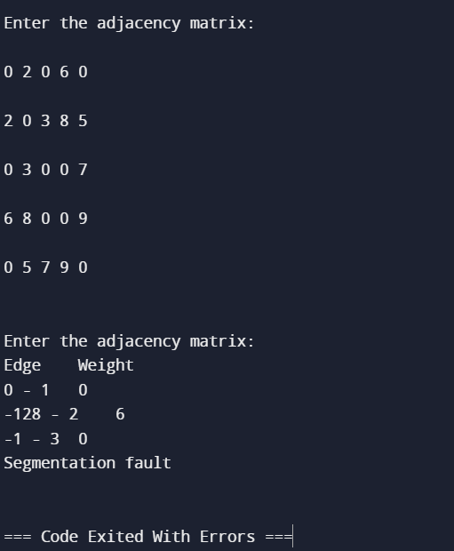

**14.IMPLEMENTATION OF DIJIKSTRA'S ALGORITHM**

Program:

#include <stdio.h>

#include <stdbool.h>

#define MAX_VERTICES 10

#define INF 999999

int graph[MAX_VERTICES][MAX_VERTICES];

int vertices;

void createGraph()

{

int i, j;

printf("Enter the number of vertices: "); scanf("%d", &vertices);

printf("Enter the adjacency matrix:\n");

for (i = 0; i < vertices; i++)

{

for (j = 0; j < vertices; j++)

scanf("%d", &graph[i][j]);

}

}

int minDistance(int dist[], bool sptSet[])

{

int min = INF,

min_index;

for (int v = 0; v < vertices; v++)

{

if (sptSet[v] == false && dist[v] <= min)

{

min = dist[v];

min_index = v;

}

}

return min_index;

}

void printSolution(int dist[])

{

printf("Vertex \t Distance from Source\n");

for (int i = 0; i < vertices; i++)

printf("%d \t %d\n", i, dist[i]);

}

void dijkstra(int src)

{

int dist[vertices];

bool sptSet[vertices];

for (int i = 0; i < vertices; i++)

{

dist[i] = INF;

sptSet[i] = false;

}

dist[src] = 0;

for (int count = 0; count < vertices - 1; count++)

{

int u = minDistance(dist, sptSet);

sptSet[u] = true;

for (int v = 0; v < vertices; v++)

{

if (!sptSet[v] && graph[u][v] && dist[u] != INF && dist[u] + graph[u][v] < dist[v])

dist[v] = dist[u] + graph[u][v];

}

}

printSolution(dist);

}

int main()

{

createGraph();

int source;

printf("Enter the source vertex: ");

scanf("%d", &source);

dijkstra(source);

     return 0;

}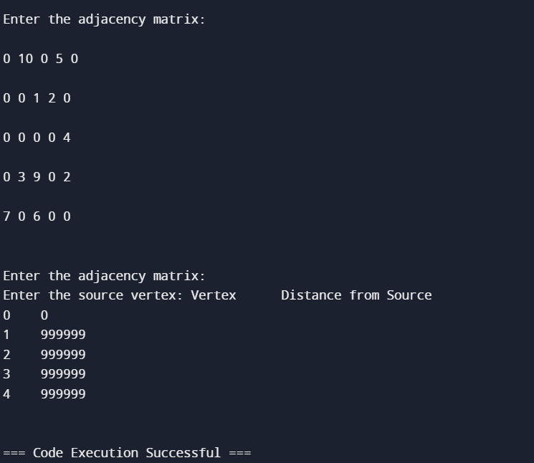

**15.PROGRAM OF SORTING**

Program:

#include <stdio.h>

#include <stdlib.h>

void swap(int *a, int *b) { int temp = *a;

*a = *b;

*b = temp;

}

int partition(int arr[], int low, int high) { int pivot = arr[high];

int i = (low - 1);

for (int j = low; j <= high - 1; j++)

{

if (arr[j] < pivot)

{

i++;

swap(&arr[i], &arr[j]);

}

}

swap(&arr[i + 1], &arr[high]);

return (i + 1);

}

void quickSort(int arr[], int low, int high)

{

if (low < high) {

int pi = partition(arr, low, high);

quickSort(arr, low, pi - 1);

quickSort(arr, pi + 1, high);

}

}

void merge(int arr[], int l, int m, int r) { int i, j, k; int n1 = m - l + 1;

int n2 = r - m;

int L[n1], R[n2];

for (i = 0; i < n1; i++) L[i] = arr[l + i];

for (j = 0; j < n2; j++) R[j] = arr[m + 1 + j];

i =0; j = 0;

k = l;

while (i < n1 && j < n2) { if (L[i] <= R[j])

{

arr[k] = L[i];

i++;

} else {

arr[k] = R[j];

j++;

}

k++;

}

while (i < n1) { arr[k] = L[i]; i++;

k++;

}

while (j < n2)

{

arr[k] = R[j]; j++;

k++;

}

}

void mergeSort(int arr[], int l, int r)

{

if (l < r) {

int m = l + (r - l) / 2;

mergeSort(arr, l, m);

mergeSort(arr, m + 1, r);

merge(arr, l, m, r);

}

}

int main() {

int n;

printf("Enter the number of elements: ");

scanf("%d", &n);

int arr[n];

printf("Enter %d elements:\n", n);

for (int i = 0; i < n; i++) {

scanf("%d", &arr[i]);

}

printf("\nSorting using Quick Sort:\n"); quickSort(arr, 0, n - 1);

for (int i = 0; i < n; i++) {

printf("%d ", arr[i]);

}

printf("\n\nSorting using Merge Sort:\n"); mergeSort(arr, 0, n - 1);

for (int i = 0; i < n; i++) {

printf("%d ", arr[i]);

}

return 0;

}

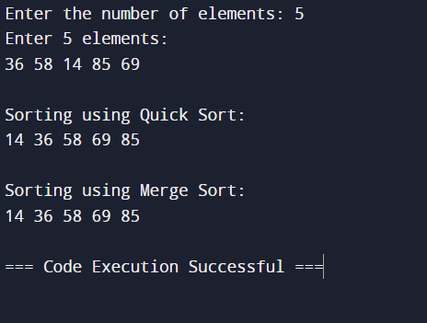

**16.IMPLEMENTATION OF COLLISION RESOLUTION TECHNIQUES**

#include <stdio.h>

#include <stdlib.h>

#include <stdbool.h>

#define TABLE_SIZE 10

typedef struct Node

{

int data;

struct Node* next;

}

Node;

Node* createNode(int data)

{

Node* newNode = (Node*)malloc(sizeof(Node));

if (newNode == NULL)

{

printf("Memory allocation failed!\n");

exit(1);

}

newNode->data = data; newNode->next = NULL;

return newNode;

}

int hashFunction(int key)

{

return key % TABLE_SIZE;

}

Node* insertOpenAddressing(Node* table[], int key)

{

int index = hashFunction(key);

while (table[index] != NULL)

index = (index + 1) % TABLE_SIZE;

table[index] = createNode(key); return table[index];

}

void displayHashTable(Node* table[])

{

printf("Hash Table:\n");

for (int i = 0; i < TABLE_SIZE; i++)

{

printf("%d: ", i);

Node* current = table[i];

while (current != NULL)

{

printf("%d ", current->data);

current = current->next;

}

printf("\n");

}

}

Node* insertClosedAddressing(Node* table[], int key)

{

int index = hashFunction(key);

if (table[index] == NULL)

{

table[index] = createNode(key);

}

else

{

Node* newNode = createNode(key);

newNode->next = table[index];

table[index] = newNode;

}

return table[index];

}

int rehashFunction(int key, int attempt)

{

// Double Hashing Technique

return (hashFunction(key) + attempt * (7 - (key % 7))) % TABLE_SIZE;

}

Node* insertRehashing(Node* table[], int key)

{

int index = hashFunction(key);

int attempt = 0;

while (table[index] != NULL)

{

attempt++;

index = rehashFunction(key, attempt);

}

table[index] = createNode(key);

return table[index];

}

int main()

{

Node* openAddressingTable[TABLE_SIZE] = {NULL};

Node* closedAddressingTable[TABLE_SIZE] = {NULL};

Node* rehashingTable[TABLE_SIZE] = {NULL};

// Insert elements into hash tables

insertOpenAddressing(openAddressingTable, 10);

insertOpenAddressing(openAddressingTable, 20);

insertOpenAddressing(openAddressingTable, 5);

insertClosedAddressing(closedAddressingTable, 10);

insertClosedAddressing(closedAddressingTable, 20);

insertClosedAddressing(closedAddressingTable, 5);

insertRehashing(rehashingTable, 10);

insertRehashing(rehashingTable, 20);

insertRehashing(rehashingTable, 5);

// Display hash tables

displayHashTable(openAddressingTable);

displayHashTable(closedAddressingTable);

displayHashTable(rehashingTable);

  return 0;

}

